**SPLITFA** **₹ E**

**A Mini-Project Report**

**Under**

**Implementation of Technology**

***Submitted by***

**Akul Gupta**

**Paridhi Goyal**

**Astha Jain**

**Ankit Makraria**

***in partial fulfillment for the award of the degree***

***of***

**B.TECH**

**IN**

**BRANCH OF STUDY**

**COMPUTER SCIENCE**

**At**

**Mukesh Patel School of Technology Management and Engineering**

**April 2015**

**CERTIFICATE**

This is to certify that the project entitled **SplitFa₹e** is the bonafide work carried out by **Akul** **Gupta, Paridhi Goyal, Astha Jain and Ankit** **Makraria** ,B.Tech (Computer Engineering), MPSTME (NMIMS), Mumbai, during the fourth semester of the academic year 2014-2015, in fulfilment of the requirements for the award of the Degree of Bachelors of Technology as per the norms prescribed by NMIMS. The project work has been assessed and found to be satisfactory.

\_\_\_\_\_\_\_\_\_\_\_\_\_\_\_\_\_\_\_\_\_\_\_ \_\_\_\_\_\_\_\_\_\_\_\_\_\_\_\_\_\_\_\_\_\_\_\_

Examiner 1 Examiner 2

\_\_\_\_\_\_\_\_\_\_\_\_\_\_\_\_\_\_\_\_\_\_\_\_

Dean

Dr. S.Y. Mhaiskar

**DECLARATION**

We, Akul Gupta, Paridhi Goyal, Astha Jain and Ankit Makraria, B.Tech (Computer Engineering), semester- IV, understand that plagiarism is defined as anyone or combination of the following:

1. Un-credited verbatim copying of individual sentences, paragraphs or illustration (such as graphs, diagrams, etc.) from any source, published or unpublished, including the internet.

2. Un-credited improper paraphrasing of pages paragraphs (changing a few words phrases, or rearranging the original sentence order)

3. Credited verbatim copying of a major portion of a paper (or thesis chapter) without clear delineation of who did wrote what.

4. We have made sure that all the ideas, expressions, graphs, diagrams, etc., that are not a result of our work, are properly credited. Long phrases or sentences that had to be used verbatim from published literature have been clearly identified using quotation marks.

5. We affirm that no portion of my work can be considered as plagiarism and we take full responsibility if such a complaint occurs. We understand fully well that the guide of the seminar/ seminar report may not be in a position to check for the possibility of such incidences of plagiarism in this body of work.

Signature of the Students:

\_\_\_\_\_\_\_\_\_\_\_ \_\_\_\_\_\_\_\_\_\_\_\_ \_\_\_\_\_\_\_\_\_\_\_ \_\_\_\_\_\_\_\_\_\_\_\_

Name:

\_\_\_\_\_\_\_\_\_\_\_ \_\_\_\_\_\_\_\_\_\_\_\_ \_\_\_\_\_\_\_\_\_\_\_ \_\_\_\_\_\_\_\_\_\_\_\_

Roll No.

\_\_\_\_\_\_\_\_\_\_\_ \_\_\_\_\_\_\_\_\_\_\_\_ \_\_\_\_\_\_\_\_\_\_\_ \_\_\_\_\_\_\_\_\_\_\_\_

Place: Mumbai

Date: April 2015

**ACKNOWLEDGEMENT**

We are really grateful because we managed to complete our Implementation of Technology assignment within the time given by our teacher Ms. Poonam Gupta. This project could not be completed without the effort and co-operation from our group members, Akul Gupta, Paridhi Goyal, Astha Jain and Ankit Makraria. We also sincerely thank our teacher Ms. Poonam Gupta for the guidance and encouragement in finishing this project and also for guiding us throughout. Last but not the least, we express our gratitude to our friends and respondents for their support and willingness.

**ABSTRACT**

**SplitFa₹e** is a simple application for keeping track of your expenses, debts and loans that you have made to your friends, family members , roommates, co-workers or anyone else with whom you have exchanged your cash. It helps track group expenses so at the end of the day everyone’s square and everyone’s happy. It gets difficult filing the shared bills every time, or writing the expenses in a diary. That is where SplitFa₹e comes into play and keeps running total all the time. At the end one can payback or take the money he/she owes or is owed from the group members. SplitFa₹e aims at fulfilling the Digital India initiative by helping people in moving from pens and diaries to mobiles for tracking their shared expenses. It makes life easy and simple and saves a person from tedious calculations. All the transactions made remain transparent to everyone therefore there are no chances of any fraud transaction.

**TABLE OF CONTENTS**

|  |  |  |
| --- | --- | --- |
| **CHAPTER NO** | **Topic** | **Page No.** |
|  | List of figures | 7 |
| 1 | **Chapter 1- Introduction** | 8 |
|  | 1.1 Problem Specification | 8 |
|  | 1.2 Solution Outline | 9 |
|  | 1.3 Application/Usage | 10 |
| 2 | **Chapter 2- System Analysis** | 11 |
|  | 2.1 Existing System | 11 |
|  | 2.2 Software Requirement | 11 |
|  | 2.3 Hardware Requirement | 12 |
| 3 | **Chapter 3- Design and Methodology** | 13 |
|  | 3.1 Flowchart of app | 13 |
|  | 3.2 Output | 16 |
|  | 3.3 Limitation of app | 34 |
| 4 | **Chapter 4- Conclusion and Future Scope** | 35 |
| 5 | References | 36 |

**LIST OF FIGURES**

|  |  |  |
| --- | --- | --- |
| Sr. No | Figure | Page no. |
| 1 | Flowchart Phase 1 | 13 |
| 2 | Flowchart Phase 2&3 | 14 |
| 3 | Flowchart Phase 4&5 | 15 |
| 4 | Icon of the App | 16 |
| 5 | Installation | 17 |
| 6 | Registration | 18 |
| 7 | Login | 19 |
| 8 | Logging In | 20 |
| 9 | Groups | 21 |
| 10 | Creating a group | 22 |
| 11 | Group Members and Leaving Group | 23 |
| 12 | Rename Group | 24 |
| 13 | Add Transactions | 25 |
| 14 | Transactions | 26 |
| 15 | Adding Members To Group | 27 |
| 16 | Group Summary | 28 |
| 17 | Features | 29 |
| 18 | My Profile | 30 |
| 19 | Preferences | 31 |
| 20 | About Page | 32 |
| 21 | Calculator | 33 |
| 22 | Tutorial | 34 |

**CHAPTER 1**

**INTRODUCTION**

**SplitFa₹e** is a free tool for friends, roommates and families to track bills and other shared expenses, so that everyone gets paid back. SplitFa₹e keeps a running total over time, so you can pay each other back in one big payment, instead of a bunch of small ones. Use SplitFa₹e to split household bills with roommates, to figure out costs for a group vacation, or just to remember when a friend spots you for lunch. SplitFa₹e makes your life easier and saves your time by doing all tedious calculations in a fast and automated manner.

* 1. **Problem Specification**

For group of people staying together, sharing household expenses becomes a tedious work. It is very difficult to keep a wise track of all the expenses incurred by everyone that has to be split equally.

Most People tend to maintain a diary for their monthly expenses.This leads to a lot of problems.People have to carry that diary everywhere they go.Not only does this cause inconvenience but it also adds to your bulk.People may forget their diary when going out which causes troubles remembering the expenses. Moreover if the diary is lost, all your expense records are lost. There can also be other issues like illegible handwriting.

Many people also tend to write there expenses on pieces of paper which may get lost. People also have a practice of filing their bills together at one place which not only wastes a lot of time and energy but also poses a risk of bills getting lost.

Even if people somehow maintain records for their expenses , the biggest issue is the calculation involved especially with a lot of transactions.The complexity of the calculations waste a lot of time and energy which could be used for doing something much more productive.There are huge chances of making errors during calculations. In order to be sure of their calculations, people tend to check it multiple times which further wastes time. There is a risk of losing the paper on which calculations are done as well.

There are constant discussions about “who paid” and “who should pay”,which leads to trust issues between friends, flatmates as nothing remains transparent. It also gets embarrassing and uncomfortable to ask friends to pay back.

* 1. **Solution Outline**

This is where our app SplitFa₹e, comes to use. The app keeps running total over time, therefore one can pay whatever he/she owes to the other members in the group at the end of every month/week.

From splitting a check at a restaurant to splitting the cable bill with your roommates, one can rack up a lot of I Owe You’s in day to day life. SplitFa₹e manages them with simple ledger and lets you pay your debts later.

SplitFa₹e provised its users with a tutorial to know and understand the working and features of the application effectively and efficientlyonce they register and log into the app.This helps them in saving their time rather than to waste time exploring and understanding the app by themselves.

SplitFa₹e allows people to make separate groups with their friends and family and add all their expenses with a description to the respective groups. A group member can also rename the group name at as and when he wishes to do so.

All the information is stored on the secure cloud servers of SplitFa₹e and there is no risk of the data getting lost. SplitFa₹e stores all your information on the cloud , so even if your phone is lost/stolen , none of your information is . Moreover you do not need to carry any diary or paper with you to keep a track of your expenses. There is no need to preserve any bills at all!

SplitFa₹e has a creative feature called preferences wherein every user has a choice to change the color theme of the app according to his/her liking. They can also choose between a darker or a lighter shade for the color theme they prefer

These preferences are even saved. Even if you logout your preferences remain the same when you login from some other or the same device..

One can also visit their account profiles and change there names and profile pictures. It can access pictures from your device and also from the internet.

SplitFa₹e also a refresh button for viewing the recent changes made in the application.

It also gives the user a choice to log out and sign in from a different account . SplitFa₹e is very easy to use and presents all group members with a complete summary of the transactions along with the respective amounts the owe to the other group members

The best thing about the app SplitFa₹e is that if a person has not paid the bill you can remind him/her through any messaging app such as whatsapp, viber etc. SplitFa₹e .

SplitFa₹e performs all the calculations of dividing the amounts automatically without you needing to even touch the calculator. Since the calculations are performed by your phone and not manually , there are no chances of any errors.

All your information is encrypted using enterprise grade hashing along with salting so there are no risks of your personal information going to wrong hands at all.

SplitFa₹e also provides instant notifications to all group members when a new transaction is made in the group.

This application also has an instant calculator wherein an amount and number of people has to be entered and it calculates the amount each person has to pay.

## **1.3 Application/Usage**

The first thing you do when you open this app is to register with your details. During registration , you have to select a password which will help you login in the future. Existing users are presented with an option to login at this stage.

Once registration/login is completed successfully, the user is presented with a list of groups he / she is a part of. Here , 2 additional options are available.The first option is the calculator option which allows the user to split a bill amongst certain number of users without adding any transaction to any group.This comes in handy when people need to split a transaction such as a restaurant bill on the spot.The second option is to create a new group which lets you create a new group.

On selecting a group from the groups list , the user is presented with a list of all the transactions of the group.Here the user is given the “Info” ,“Summary” and an “Add” option. The add option allows the user to create a new transaction in the group.The user has to enter a meaningful description and an amount for each transaction.Selecting the Summary option displays the user with a bird’s eye view of all the transactions by displaying the totala expenditure , respective amounts paid by the group members and his/her total outstanding amount.

On selecting the info option in the transactions view , the group details are shown which lists the people currently in the group and the group name. Here the user is given two additional options .The first option is to add a new member to the group.On selecting this , the user just needs totype the email id of the person to add and the person will be added to the group ! The second option allows to change the name of the group.The user just needs to enter a new name for the group and the group will be renamed.

Every expense added by a member in the group gives the other members a notification at that very moment.

**CHAPTER 2**

**SYSTEM ANALYSIS**

# 

**2.1 Existing System**

ADVANCED BILL SPLITTER

Advanced bill splitter allows people to split bills instantly.It does however not provide functionalities of group creation and cloud storage which is very inconvient. Moreover the app does not provide instant notifications to other users when a transaction is made.

## **2.2 Software Requirement**

**Minimum Required Software Requirements:**

* Android 4.0 (Ice Cream Sandwich) or Higher
* Google Play Services must be installed on your phone
* Google Cloud Messaging Framework must be Installed On your Phone
* A Google Account must be associated with the phone

**Recommended Software Requirements:**

* Android 5.0 (Lollipop) or Higher
* Latest Version Of Google Play Services must be installed on your phone
* Latest Version of Google Cloud Messaging Framework(GCM) must be Installed On your Phone
* A Google Account must be associated with the phone

## **2.3 Hardware Requirement**

* A fully working Internet Connenction
* Atleast a 1.0ghZ dual core CPU for smooth operation
* Atleast 512MB Ram
* Minumum HDPI(480X800) Screen for the visuals

**CHAPTER 3**

**DESIGN AND METHODOLOGY**

## **3.1 Flowchart of Apps**

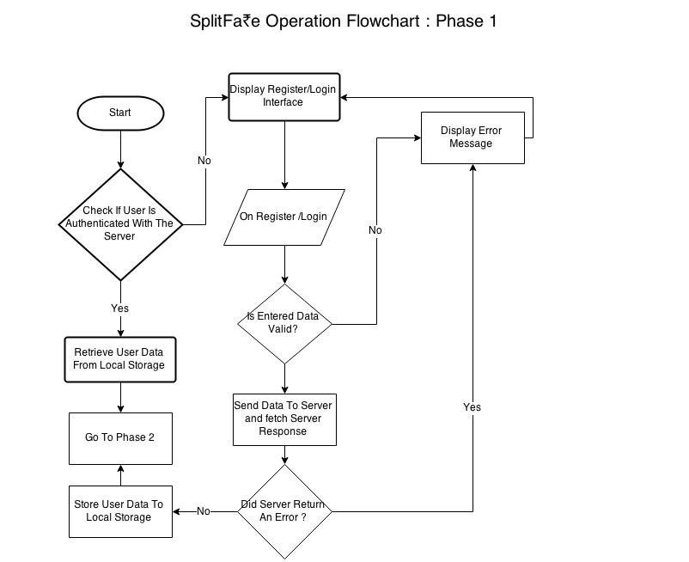

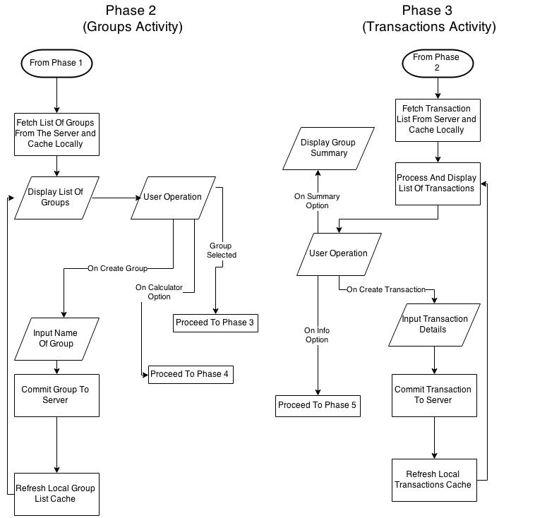

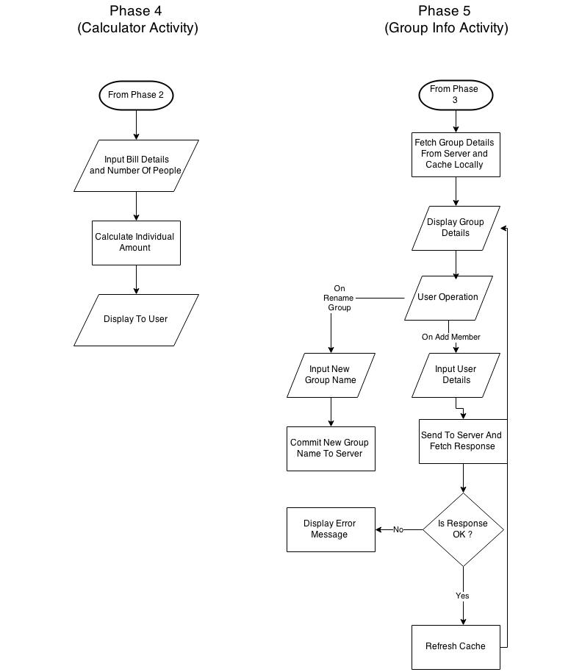.

**3.2 Output (Screenshot of the app)**

**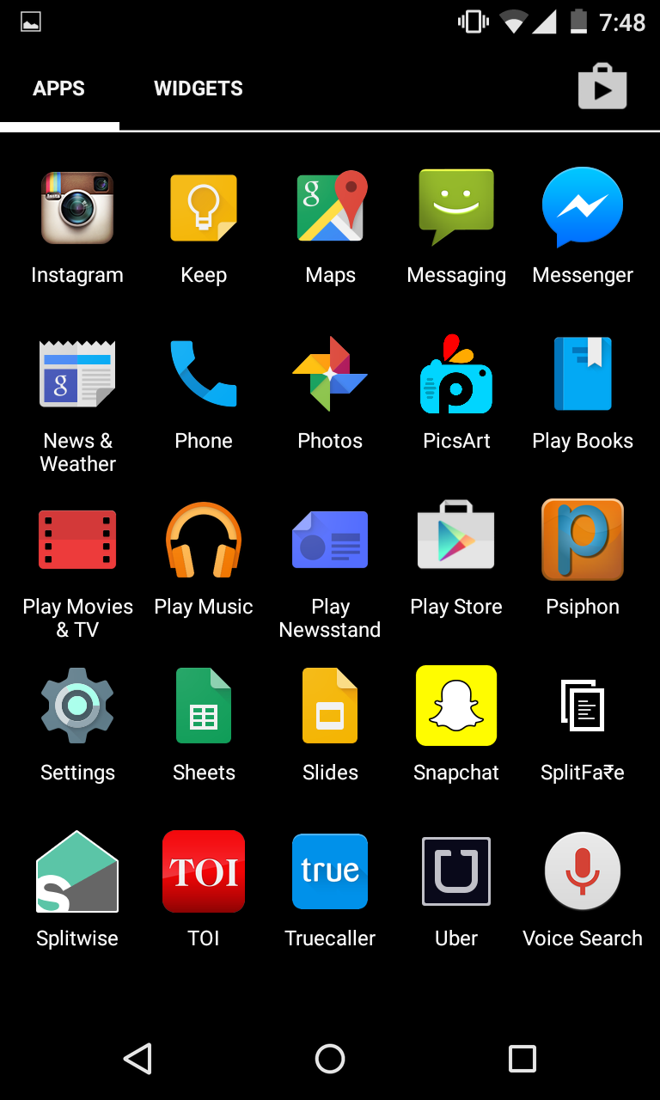**

Fig 1: Icon of the App

## Screenshot_2015-04-02-11-57-37.png

Fig 2: Installation Of App

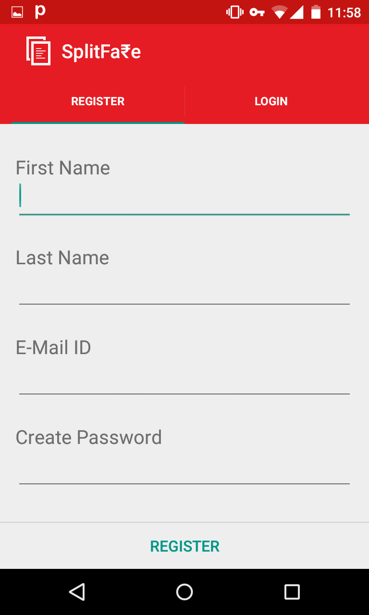

Fig 3: Registration

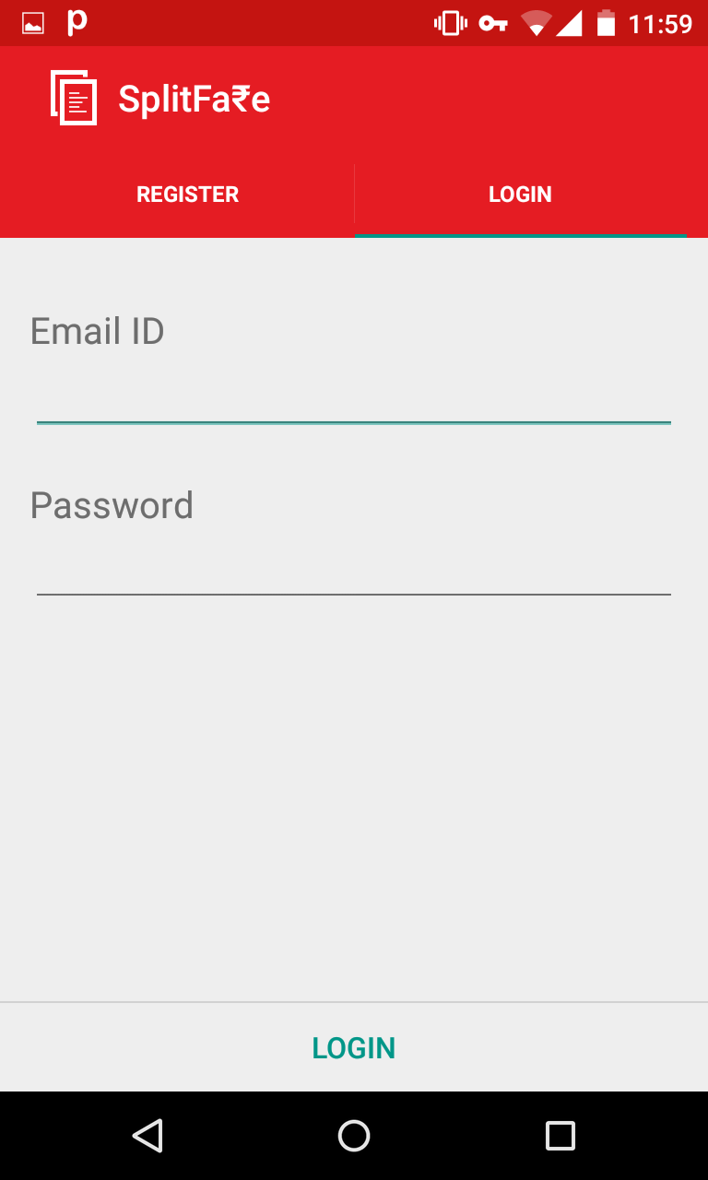

Fig 4:Login

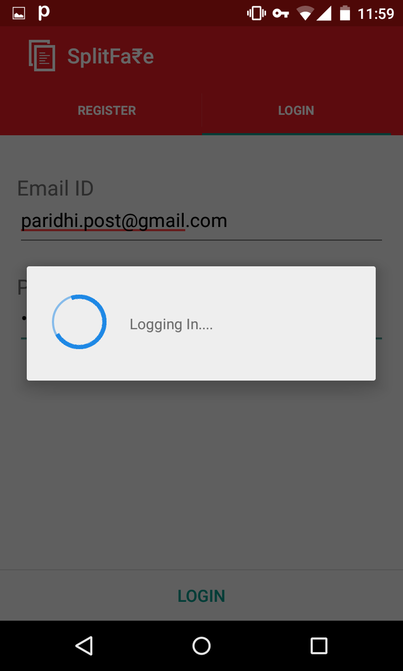

Fig 5: Logging In

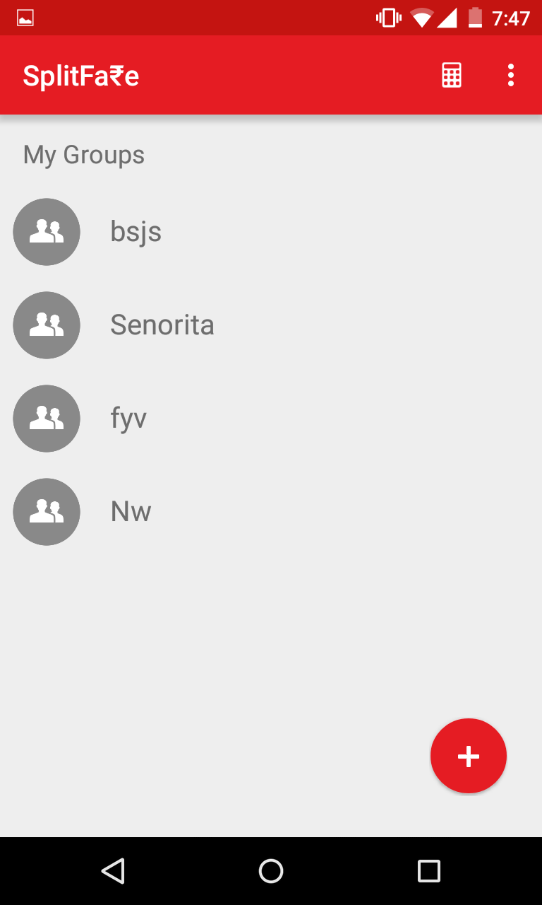

Fig 6: Groups

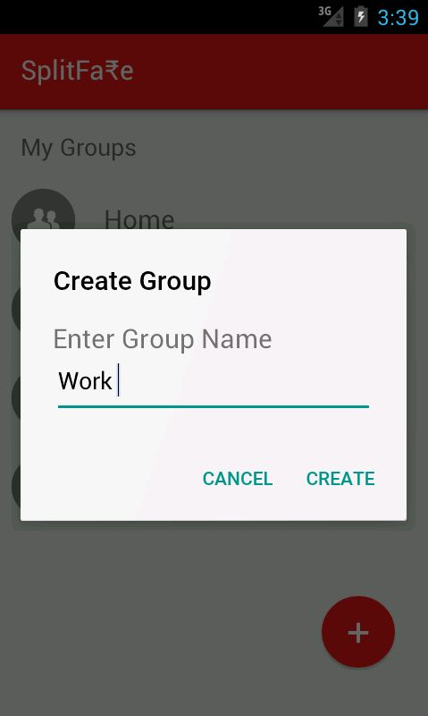

Fig 7: Creating Group

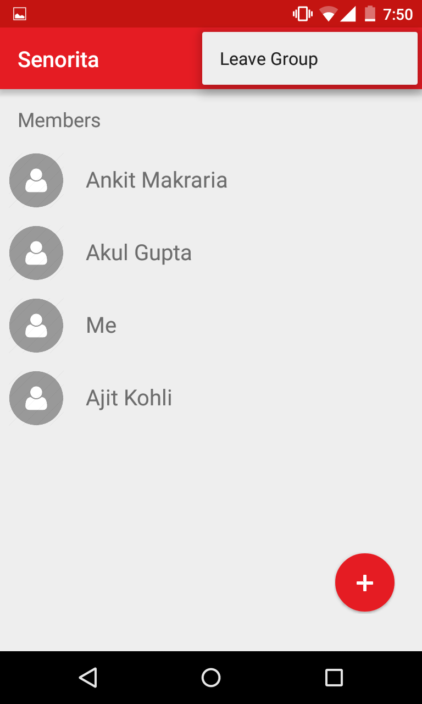

Fig 8:Group Members and Leaving Group Option

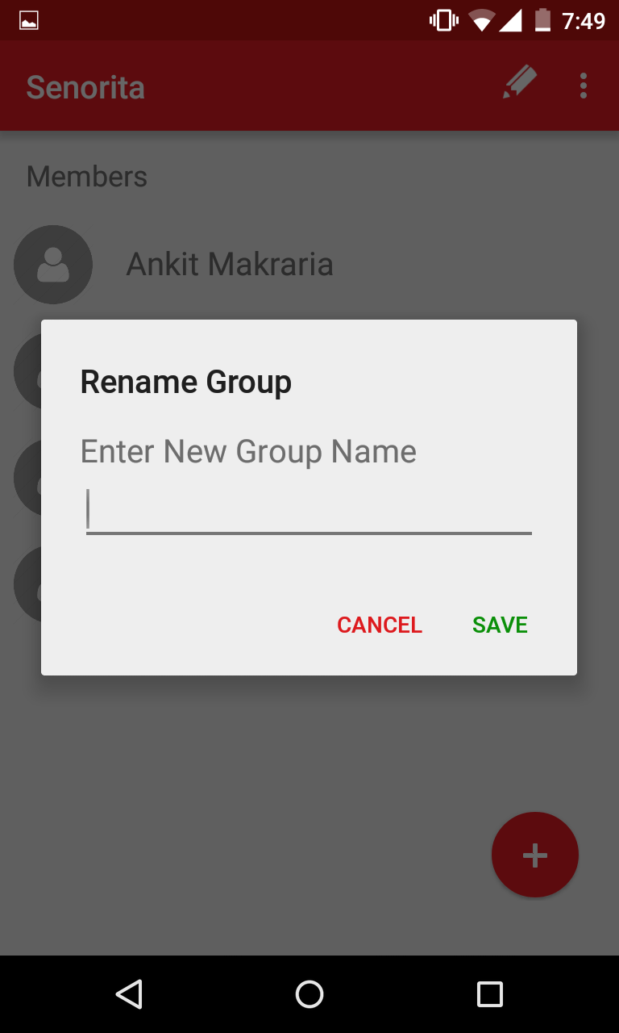

Fig 9: Rename Group

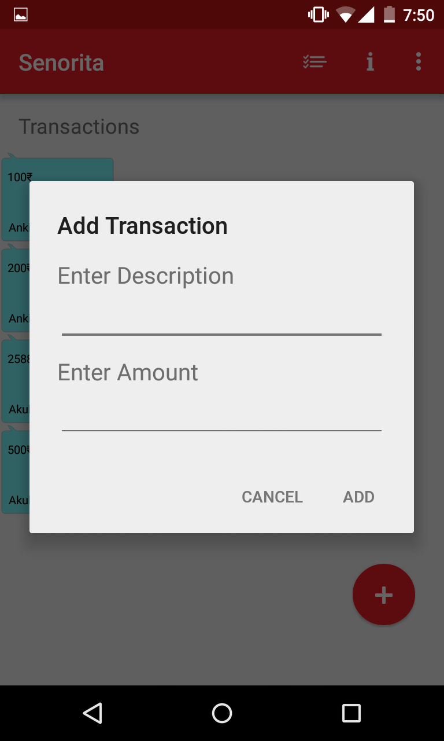

Fig 10 : Add Transaction

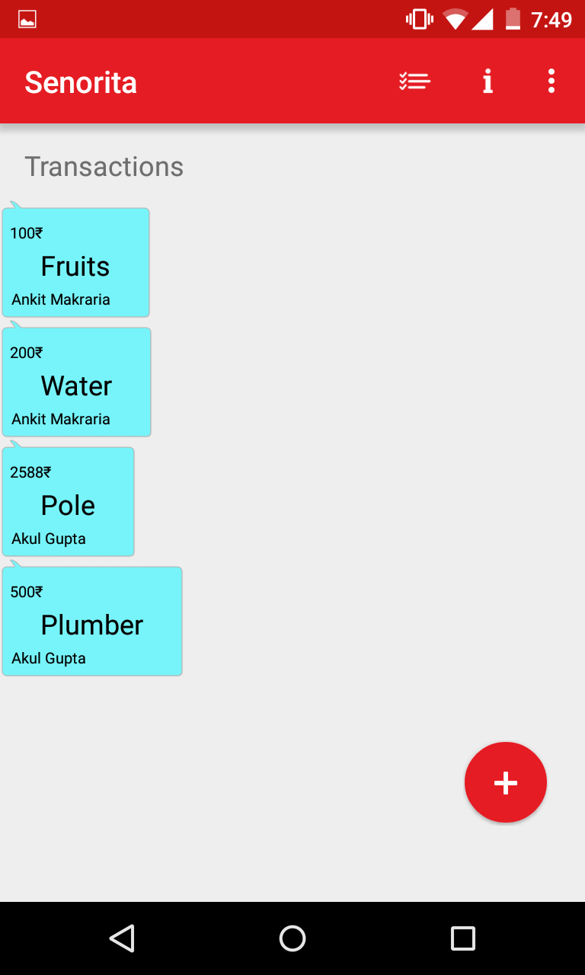

Fig 11:Transactions

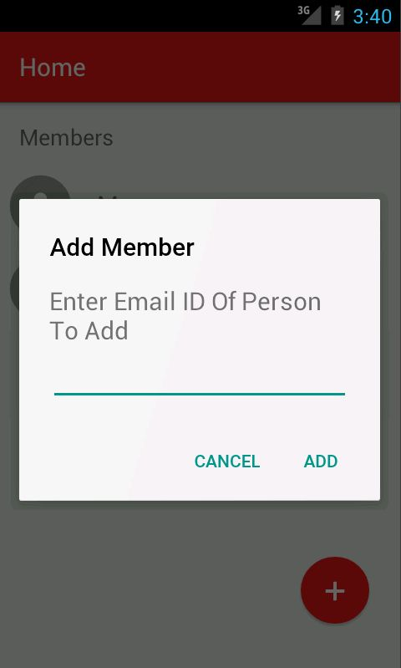

Fig 12: Adding Person To Group

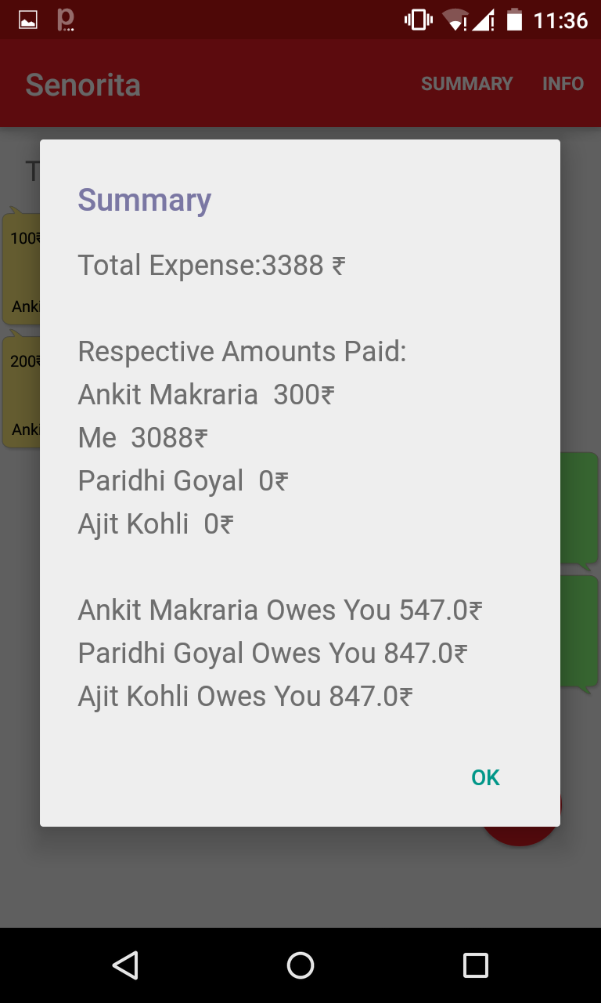

Fig 13:Group Summary

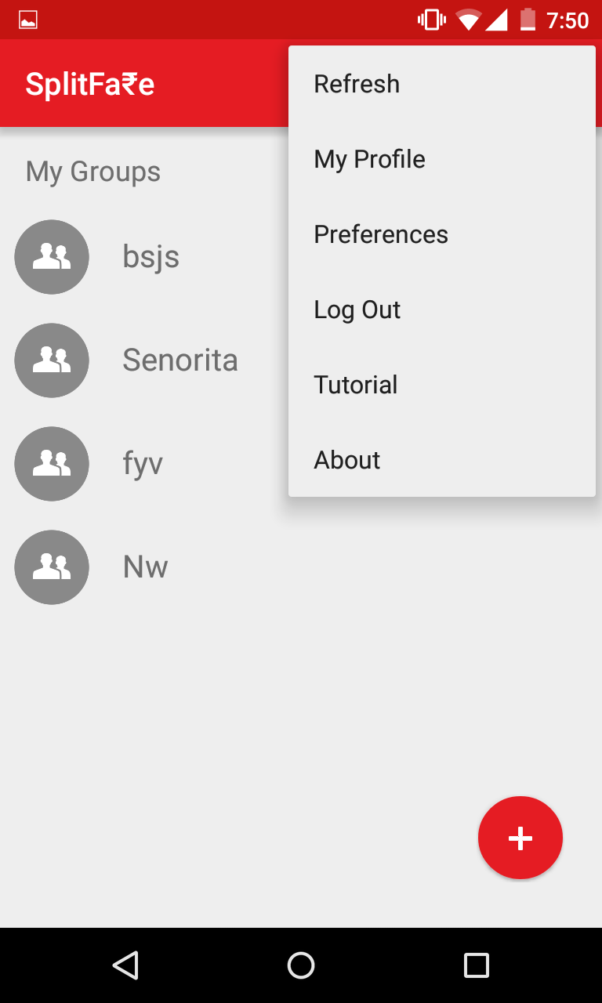

Fig 14: Features

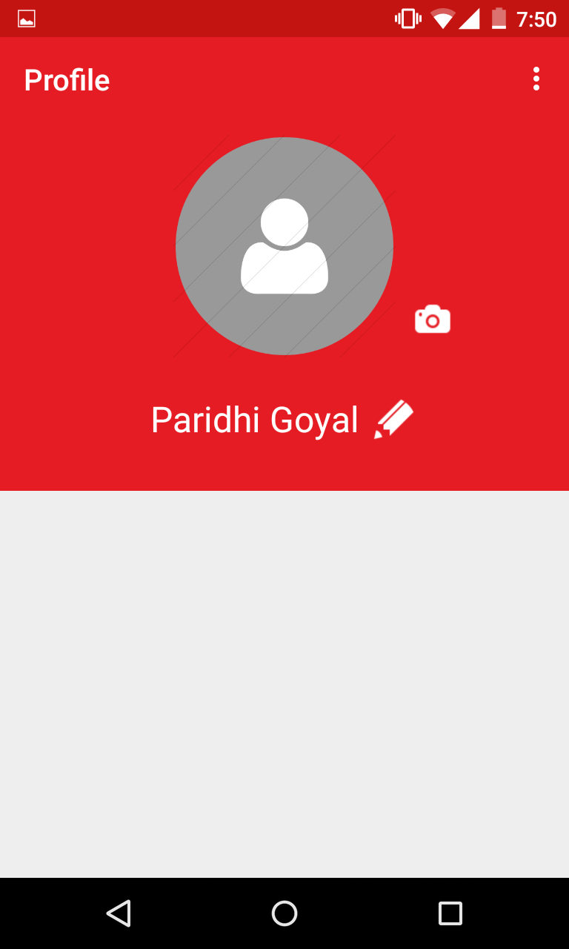

Fig 15: My Profile

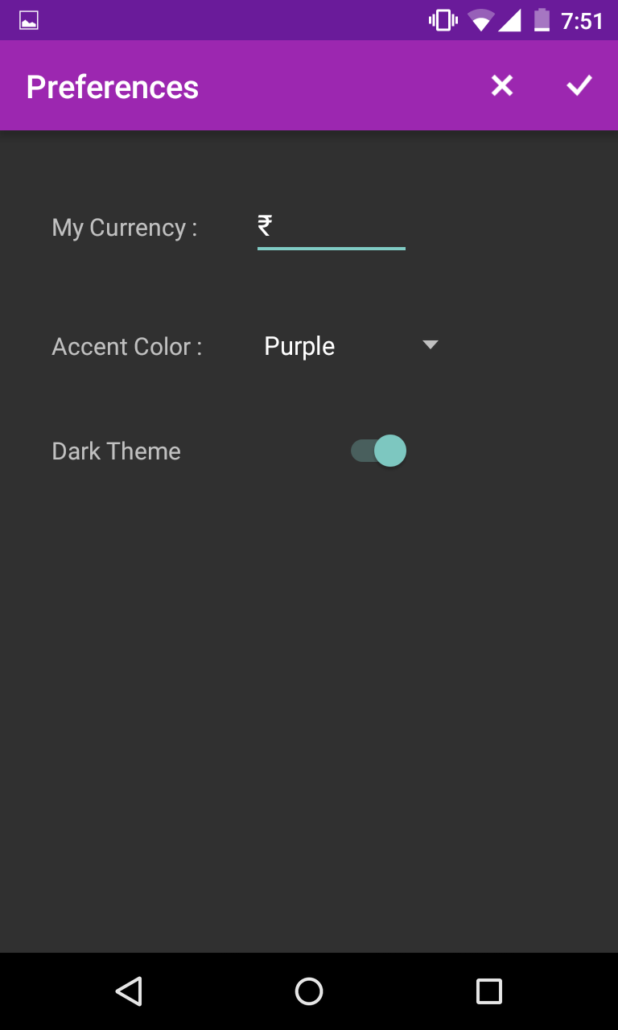 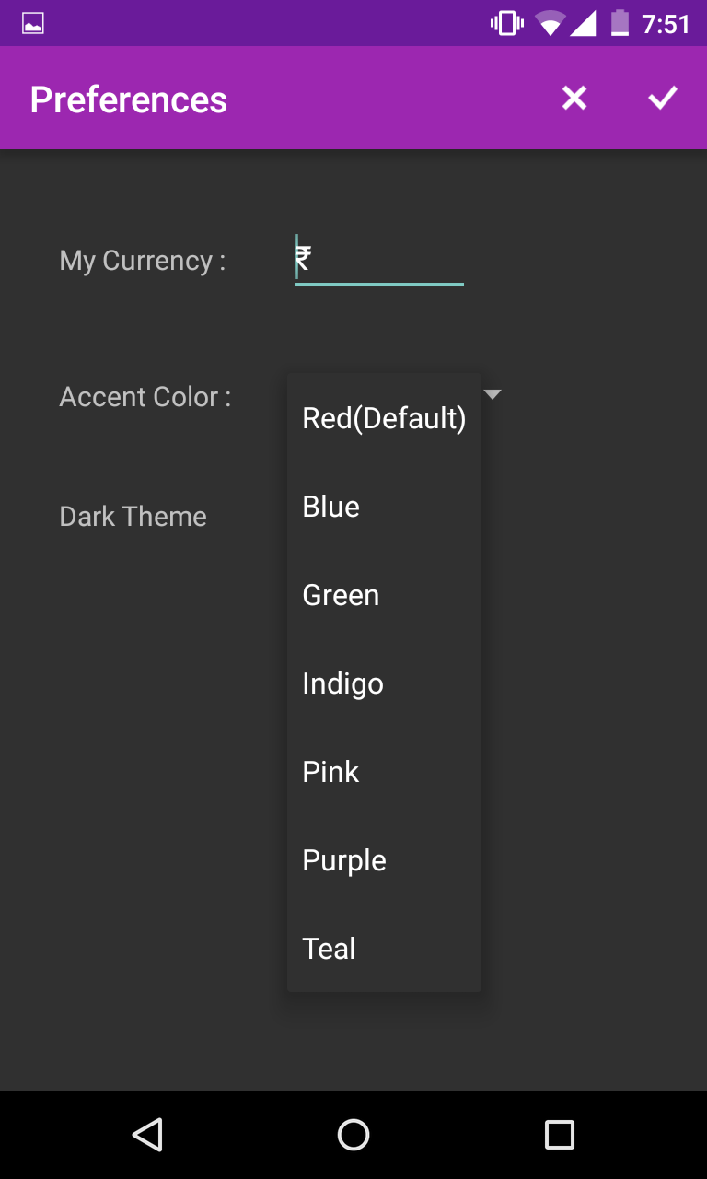

Fig 16: Preferences

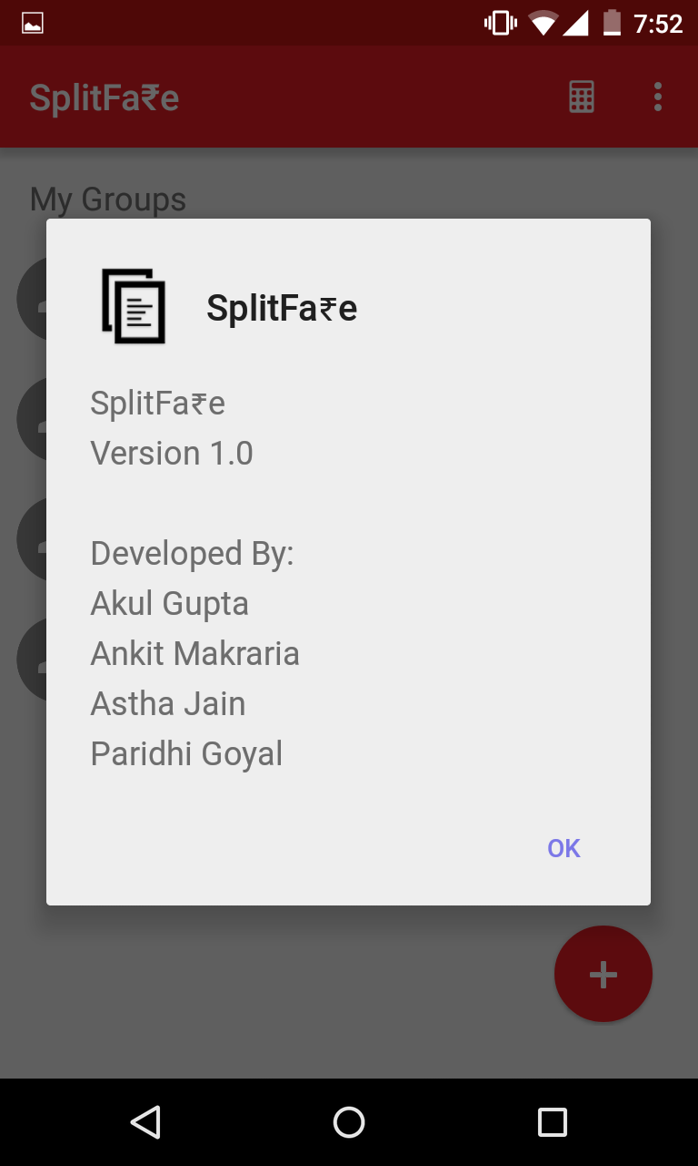

Fig 17: About Page

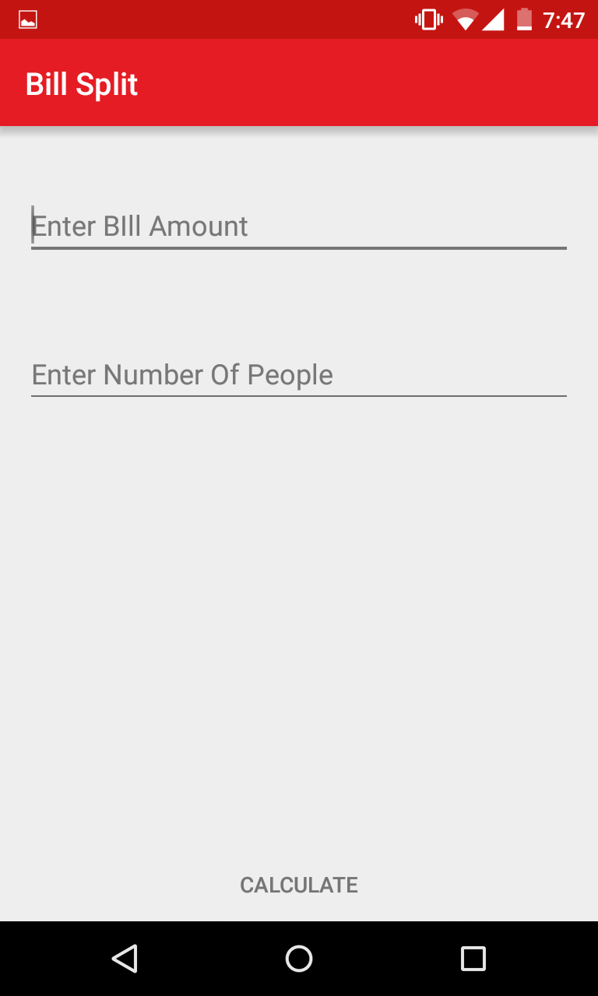

Fig 18: Calculator

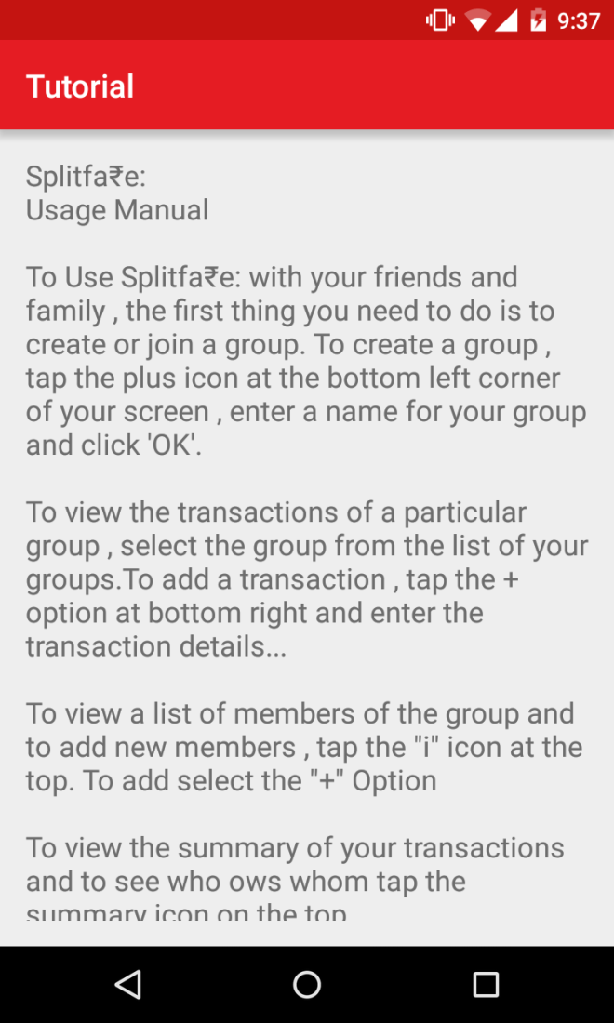

fig 19: Tutorial

## **3.3 Limitations of App**

* There is no option of splitting the bills amongst only selected members of a group
* Not cross platform
* No Login From Facebook or Other Social Networks using OAuth Protocol

**CHAPTER 4**

**CONCLUSION AND FUTURE SCOPE**

**SplitFa₹e** is a expense sharing tool for friends, roommates and families to track bills and other shared expenses, so that everyone gets paid back. It keeps a total over time, so that people can pay each other back in one big payment, instead of a bunch of small ones.We can use SplitFa₹e to split household bills with roommates, to figure out costs for a group vacation, or just any other expense. SplitFa₹e makes your life easier and saves your time by doing all tedious calculations in a fast and automated manner.

This application is currently only available to android users only. We will expand this to other platforms like iOS , Windows Phone and Blackberry. We will also allow web based access to SplitFa₹e so that nobody gets left out

Many times , not all expenses need to be divided equally amongst all the group members. As of now , SplitFa₹e does not allow unequal division of expenses , however this option can be added in the future to make the app better.

There are scenarios when people tend to return / replace purchased items.In this case , the older transaction needs to be removed from the group.Currently , the app has no such option , however such an option can be added to make the app better.

The application is accessible only throuhg a valid Email-ID and a person can not use this application by logging in through a facebook account or any other social networking website .We plan to overcome this limitation in near future.

**REFERENCES**

**Libraries Used**

* Google Play Services
* Google Cloud Messaging
* MaterialDialogs (https://github.com/afollestad/material-dialogs)
* MaterialDesign (<https://github.com/navasmdc/MaterialDesignLibrary>)
* Facebook Android SDK (<https://github.com/facebook/facebook-android-sdk>)

**Web References**

StackOverflow Forums (<http://stackoverflow.com/>)

Android Material Design (<https://developer.android.com/design/material/index.html>)

Android Google Cloud Messaging (https://developer.android.com/google/gcm/index.html)